**Exp 1b: Cloud9 Setup and Launch, Collaboration demonstration by creation of IAM groups and users.**

1. Open your AWS account and search for Cloud9 service inside Developer tools. Create a new Cloud9 environment by filling in the required details. Make sure you use an EC2 instance to create your environment.

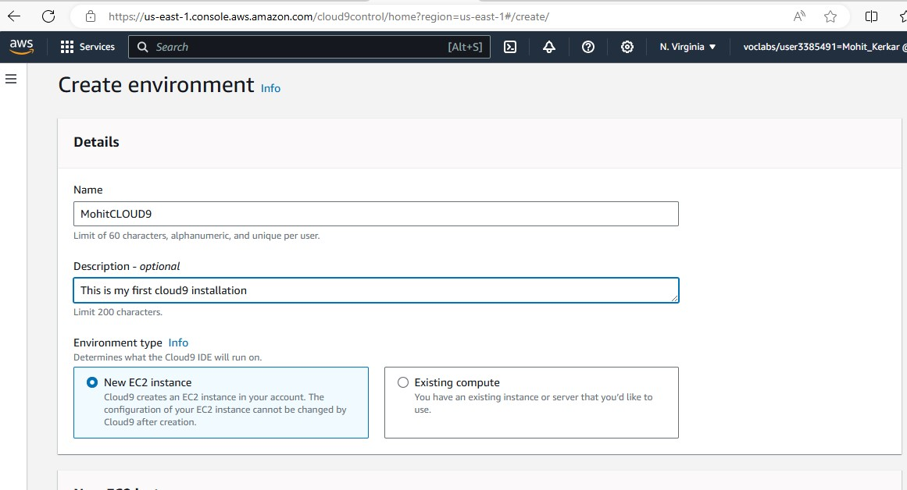

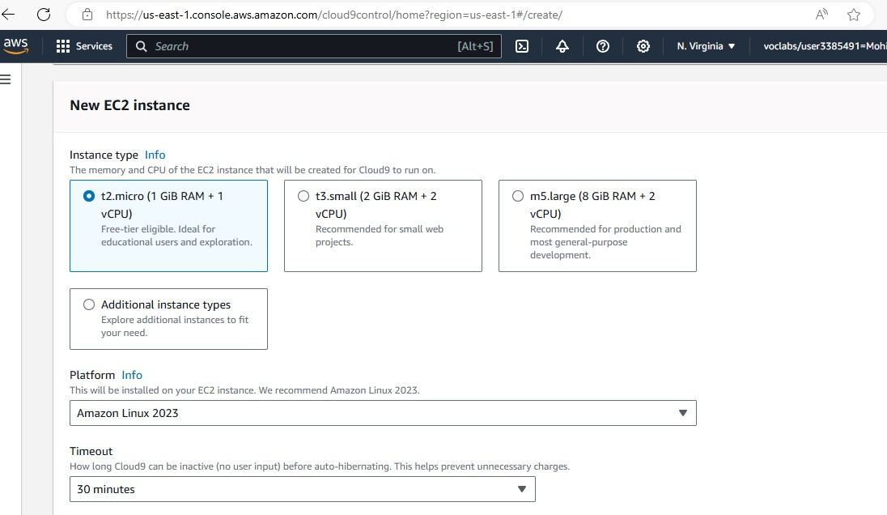

1. 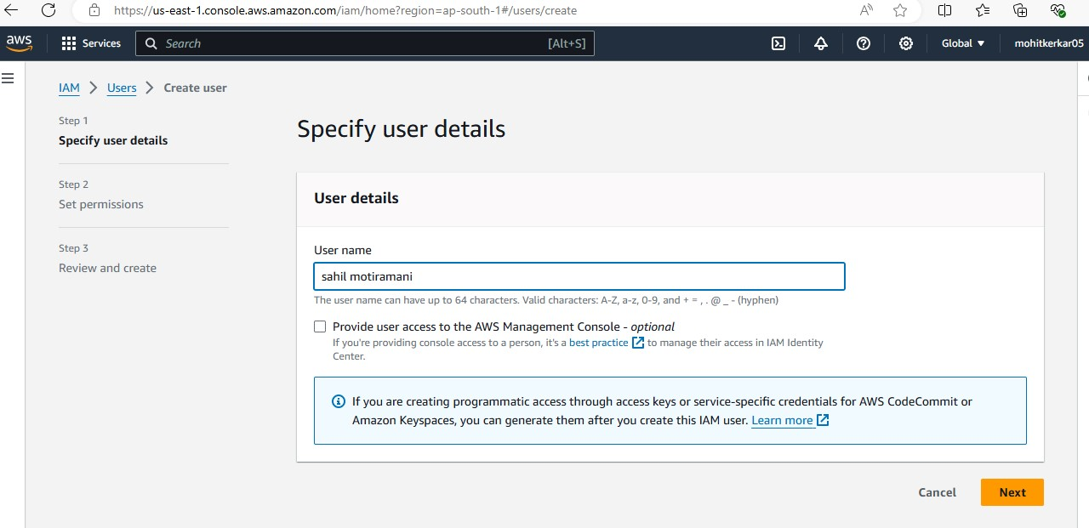We have successfully setup and launched our Cloud9 environment. Over here, we can build and develop programs as per our desire. We are also allowed to collaborate with multiple other users and access shared resources.

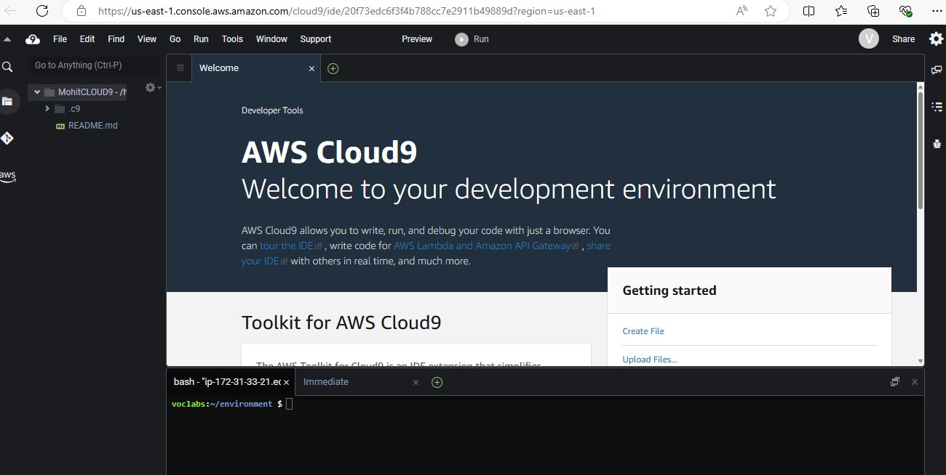

1. Moving on, we are supposed to create a new user. Give a suitable name to the user and decide the password for the same.

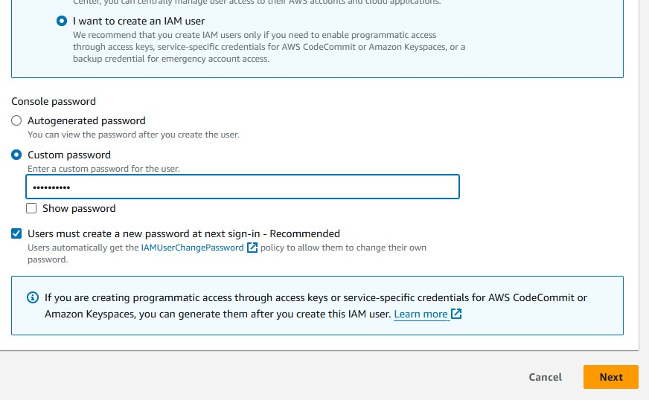

1. Similarly, create a new group and provide a suitable name for the same. Include the IAM users in this group together for our convenience i.e to provide similar kinds of permissions to the entire group rather than an individual user.

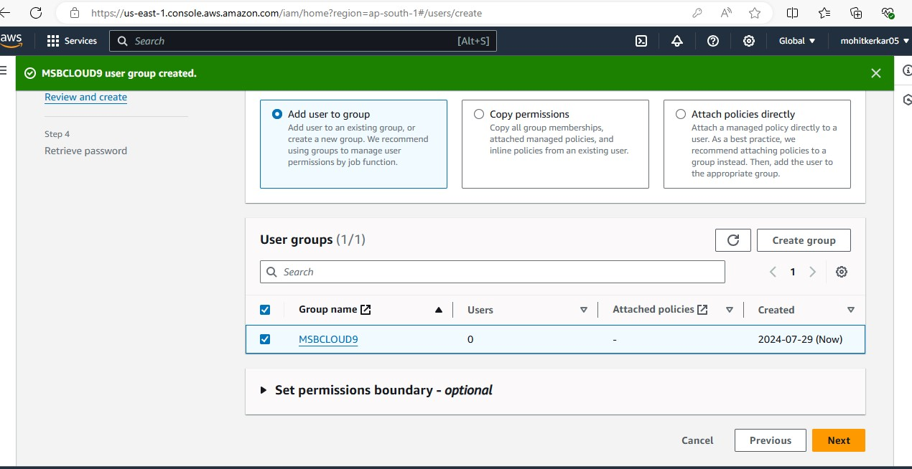

1. The user has successfully been created i.e There is a custom made username and a password for the IAM user.

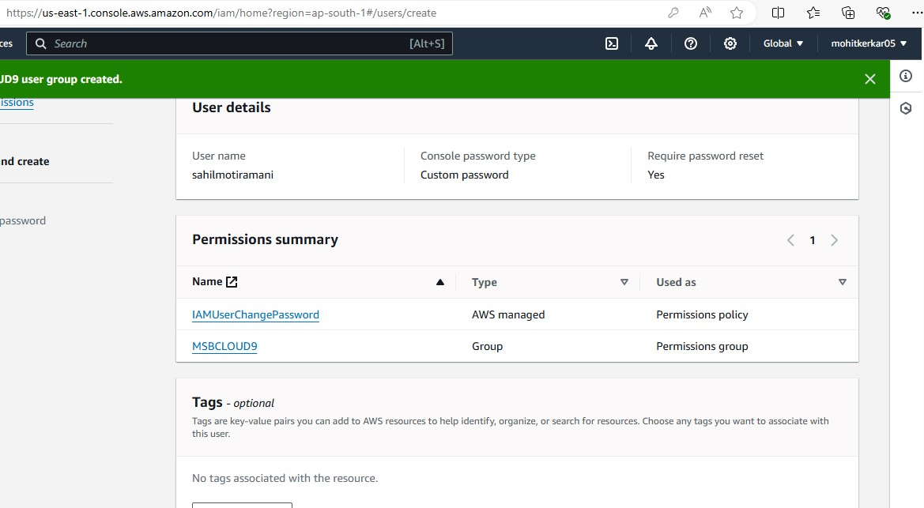

1. Go back to the cloud9 environment. Click on share this environment option so as to allow other collaborators to access you environment. Include your newly made IAM user in this environment and enable Read/Write permissions for it

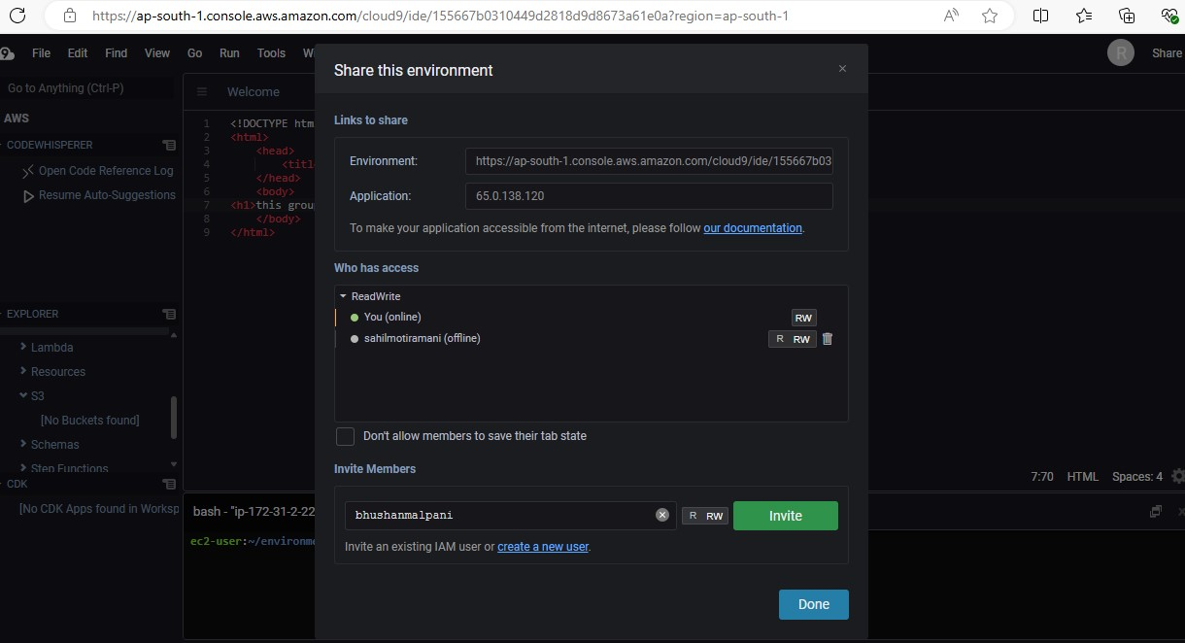

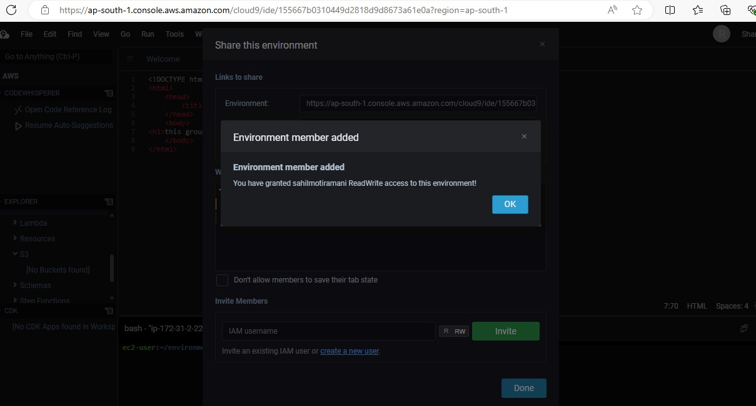

1. Further, we are supposed to login from another browser using the credentials of the IAM user, so as to access the shared cloud9 environment with us.

These steps could not be completed because Cloud9 services have been disrupted and there is no access to the IAM user from the remote login